**ASSIGNMENT-1**

**Project Name:** **IOT based Gas Leakage monitoring & Alert system for Industries**

**Assignment Given**: **Gas Leakage monitoring & Alert system for Industries**

# Team Lead : Rahul I

# Team Member 1: Saravanan N

# Team Member 2: Vijayaraj C

# Team Member 3: Vishvanth R

*Nalaiyathiran*

Before Simulation:

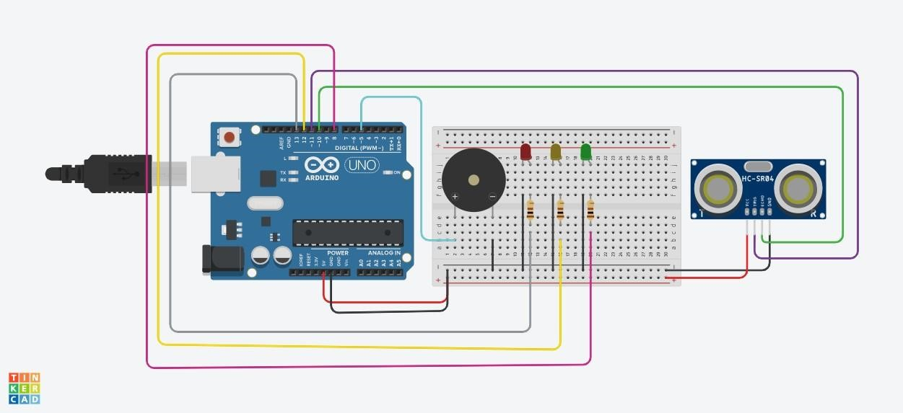

After Simulation:

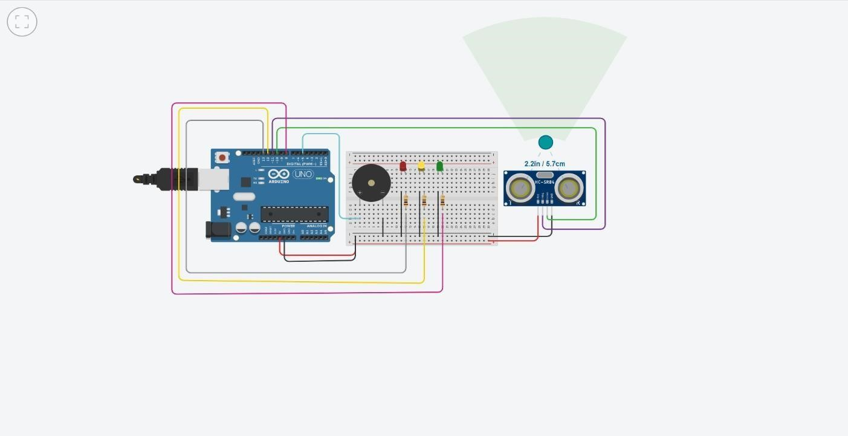

**Code:**

